# INFO 6150 Module 3

Yiran Chen

002839117

1. Website map

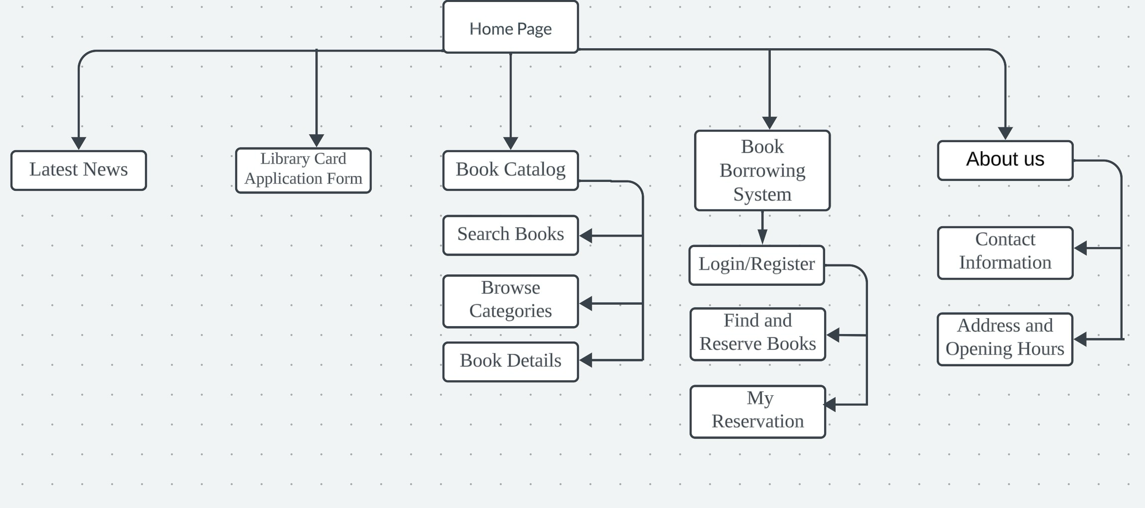

1. box diagram

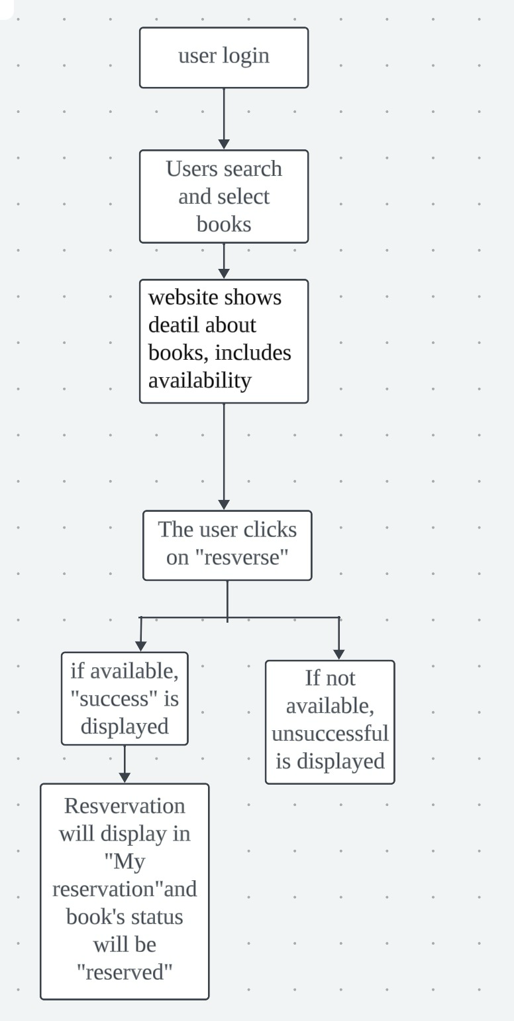

1. How shold users navigate between pages?

Top Navigation Bar: Includes links to all major sections (Home, Library Card Application Form，Book Catalog，Book Borrowing System，About us).

1. How will it be possible to find a specific book? Think of all possible alternatives and select at least two. Justify your choices.

Search function: Allows users to search by title, author, etc., providing a quick way to find a specific book.

Categorization and Filtering: Categorizes books by genre, new arrivals, popularity, etc. Availability, Age Group, Language Filters. This helps users discover books when they are not sure what to look for.